PRINCETON ENGINEERING COLLEGE AND TECH
HYDERABAD 501301, ANDHRA PRADESH
DEPARTMENT OF ELECTRONICS AND COMMUNICATIONS

CERTIFICATE

Certified that the project work entitled FREND FINDER USING BLUETOOTH is a bonafied work carried out by (D. Chandra Babu, K. Raghavender Reddy, K. Rajendar Reddy, T. Naveena) in partial fulfillment for the award of degree of Bachelor of Technology in Electronics and Communication Engineering from Jawaharlal Nehru Technological University, Hyderabad during the year 2005-06. It is certified that all corrections/ suggestions indicated for Internal Assessment have been incorporated in the Report deposited in the departmental library. The project report has been approved as it satisfies the academic requirements in respect of Project work prescribed for the Bachelor of Technology Degree.

Signature of the Guide Signature of the HOD Signature of the Principal

Name of the students D. Chandra Babu (02L71A0439)
K. Raghavender Reddy (02L71A0401)
K. Rajendarr Reddy (02L71A0455)

External Viva
Name of the examiners Signature with date

1.

2.

A

PROJECT REPORT

ON
“Friend Finder”

A dissertation submitted towards partial fulfillment of
Degree of Bachelor of Technology
in Electronics and Communication Engineering
(Jawaharlal Nehru Technological University, Hyderabad)

SUBMITTED BY

D. Chandra Babu (02L71A0439)
K. Raghavender Reddy (02L71A0401)
K. Rajendarr Reddy (02L71A0455)
T. Naveena (02L71A0458)

DEPARTMENT OF ELECTRONICS AND COMM ENGINEERING
PRINCETON COLLEGE OF ENGINEERING AND TECHNOLOGY
HYDERABAD (ANDHRA PRADESH)
ORGANIZATION PROFILE

The Company

Renaissance is a global technology company with proven software development, consulting and mentoring for global enterprises. Renaissance is started by a group of seasoned and accomplished IT professionals with a rich blend of complementing expertise essential to make it successful ventures.
At Renaissance, we work hand in hand with Global IT Industry leaders creating Intellectual property. In a short span we have been successful in setting up office and attracting clients from different countries like USA, Saudi Arabia, Germany, Singapore and Australia.

Team

The core team members of Renaissance have, in the past, were directly responsible for delivering large scale software solutions to some of the biggest companies in the world including Hewlett-Packard, Sun Microsystems, IBM, General Motors, Qwest and Version, accredited diagnostic centers and industry leaders in various domains.

Infrastructure

Renaissance has a well-equipped and networked lab with relevant software and dedicated Internet access. It also has a special state of the art mobile communications lab to develop next generation mobile applications. A library of knowledge resources in term of journals, articles, CD’s is an integral part of the never ending process of learning.

Renaissance-ISO-9001 Compliance

Renaissance firmly believes in quality software development meeting international standards. They have an elaborate in-house quality control process and separate quality assurance group to monitor all aspects of quality. They have a well-laid down QA policy based on best software engineering practices followed across the globe. The robust quality policy at Renaissance is currently undergoing ISO certification process.

Renaissance Partners

Renaissance has forged strong global alliances in technology arena to be able to work on cutting edge technologies.
Notable Global partners of Renaissance include:
NOVELL
SUSE LINUX
XIMIAN

Renaissance Clients

Renaissance has a healthy client base in domestic as well as international markets. Some of the prominent clients include:

Hewlett-Packard

Nokia
Leap stone
Infer data Inc
Deccan Diagnostics and Research center
Genesis

Idealabs Initiative

As part of its pioneering initiative, Renaissance has launched a unique program called IDEALABS-THE INCUBATION PROGRAMME. Renaissance incubation program is a matchless package of core concepts and project internship.
The program aims at transforming student force into and industry ready Engineering workforce.

Renaissance has tied up with several international companies for forming and mentoring Developer Communities

ACKNOWLEDGEMENT

At the outset, I acknowledge my deep sense of gratitude to Mr. Pankaj Diwan, CEO of Renaissance Infotech, Secunderabad for giving me permission to do the project in their organization.

We would like to express our sincere thanks to Mr. K. Naveen Kumar and Mr. Vinod Goud, our external guides for their excellent guidance, without which this project would not have been possible. Their wholehearted and kind co-operation has made the project successful. We are extremely grateful to them for conferring all their assistance on our project.

We are grateful to MR SHARMA SIR, Head of the Department, Department of Electronics And Communication Engineering, Princeton College of Engineering and Technology, for all the help he has extended.

We wish to express our deep sense of gratitude to MR. VISHNU VARDHAN SIR, Department of Electronics and Communication, our internal guide, for his extended cooperation and all his important suggestions and advice. His constant motivation and concern have been invaluable.

Our appreciable obligation also goes to all staff members of Electronics and Communication Department and to our fellow classmates who directly or indirectly helped us.

Finally, we would like to thank our family and friends for their moral support and encouragement.

ABSTRACT

The project entitled “Friend Finder” is to find new friends using a Mobile Phone. The communication between two Mobile takes place using BLUETOOTH. “Friend Finder” is the application software used in Blue tooth enabled mobiles to overcome some problems we generally face in the current world, similar to the below mentioned situations.

- While we are waiting in busy places where you don’t know any person to talk. Friend finder will help you to search for new friends around us depending upon their profiles, we select.

- Searching our friends in crowded places, in some occasions like Alumna’s of schools or
colleges are made easier by using friend finder. Hence problem of finding our friends in the crowded places is made easier and more comfortable.

The form interface needed to connect one mobile to another using JAVA, JAVA provides a flavor of J2ME whose programs are compiled and executed using the Compiler Edit plus. The forms for the Mobile Phone are first emulated on an emulator, later this is loaded into the Mobile Phone.

The project is based on peer to peer communication where transfer of List of profiles takes place between the mobile & mobile. An attempt has been made to search for the desired profile in the vicinity. Based on the services in the other mobile the mobile is searched and displayed, which is searched by a program developed in J2ME, which uses the information provided by the Mobile Phone in its RMS. The commands have been sent from one Mobile Phone to another Mobile Phone using BTSPP protocol.

TABLE OF CONTENTS

- INTRODUCTION
2. LITERATURE SURVEY
3. SYSTEM SPECIFICATIONS
4. SOFTWARE REQUIREMENT SPECIFICATION
5. DETAILED DESIGN
5.1 BLOCK DIAGRAM
5.2 SUBSYSTEMS
5.2.1 DESIGN OF USER INTERFACE
5.2.2 BLUETOOTH COMMUNICATION
5.2.3 LISTENER MODULE
5.3 USE-CASE DIAGRAM
5.4 SEQUENCE DIAGRAM

6. TEST CASES
6.1 TO ESTABLISH A CONNECTION.
6.2 TEST FOR SENDING A MESSAGE
6.3 TEST FOR QUERY PASSING
6.4 TEST FOR SENDING VIDEO FILES
6.5 RECEIVING ALERTS FROM PC
6.6 TESTING OF COM PORT

7. CONCLUSION AND FUTURE SCOPE
8. APPENDIX
8.1 GLOSSARY
9. BIBILIOGRAPHY
10. REFERENCES

INTRODUCTION

1.1 OVERVIEW OF THE APPLICATION

The project titled “Controlling of Devices using Mobile” (PC REMOTE CONTROLLER) is developed to control the Electronic Appliances that are present in Home using a Mobile Phone.
The communication between the Mobile and the Home Appliances takes place using Bluetooth provided the devices are Bluetooth enabled. Bluetooth is a Wireless technology that is used to connect and control the devices via wirelessly within a short range. This technology uses RF as the medium, which provides a serial port or link for Data Transmission.
Symbian OS, a specially designed software for mobile phones acts as an interface to connect and control in the mobile and is programmed in Symbian C++ and is compiled and executed using the WINS, ARMI compilers. The screens for the are first emulated on an emulator called EPOC, a proprietary software of Nokia and later the program is loaded onto the mobile.
In this project an attempt has been made to control the Windows Media Player in the PC, which is activated by a program developed in Visual Basic 6.0 at the PC side, which uses the control information provided by the Mobile.

1.2 FEASIBILITY STUDY

Many feasibility studies are disillusioning for both users and analysts. First, the study often presupposes that when feasibility document is being prepared, the analyst is in a position to evaluate solutions. Second, most studies tend to overlook the confusion inherent in the system development – the constraints and the assumed attitudes. If the feasibility study is to serve as a decision document, it must answer 3 key questions:
Three key considerations involved in the feasibility analysis:
- Economical
- Technical
- Behavioral

1.2.1. ECONOMIC FEASIBILTY:

This project is developed at Renaissance InfoTech. Ltd. , which is well equipped with all the latest software and hardware. This application on the client side has been developed using Series 60 SDK for Symbian OS which is open source software. The application on the PC side has been developed using Visual Basic. The hardware required is a Bluetooth adapter, which is not expensive. Hence the application is economically feasible.

1.2.2. TECHNICAL FEASIBILITY:

As the application has been developed using Series 60 SDK for Symbian OS and the front end as VB, which utilize minimum resources of the Personal computer, this project is technically feasible.

1.2.3. BEHAVIORAL FEASIBILITY:

This project has been implemented by BTPOINTTOPOINT LABS and it satisfies all the conditions and norms of the organization and the users.

LITERATURE SURVEY

2.1 CURRENT INDUSTRY SCENARIO

Historically the wireless industry has been technology driven, with mixed results. Uncertain demand for new mobile services now makes investment in the right technology critically important. A myriad of emerging wireless technologies, surrounded by hype and confusion, now offer a range of alternative evolution paths. Mobile messaging and small-screen browsing grow strongly, maintaining a huge gulf between mobile and fixed capabilities. Organizations must be prepared for diverse alternative futures. It is imperative for players to be pro-active in driving the industry in the most favorable direction.

Bluetooth technology has seen some consumer uptake. Use of the technology in a more wide-ranging set of environments is imminent, most notably for a host of indoor functions including information, work, entertainment and safety/recovery. The near future holds scenarios where home-entertainment, in-car navigation, mobile communication and road-side assistance work from integrated systems.

Increase in the usage of the Mobile phones has increased the complexities in interconnecting these devices. Different interconnecting technologies have been proposed which coming up with their innate capabilities and limitations answering the current industry standards and issues where its counter fails. While adopting any technology the factors such as setup cost, compatibility with the existing infrastructure has to be considered. Demand for effective Mobile Devices providing better Quality of Service(QoS) has increased.

The present day Home Appliance available in the market could be controlled Wirelessly with the remote controller, but these remote controllers suffer from the problem of line of sight i.e., if the angle of incidence is more than 30 degrees from the normal, the signal will not reach the destined device, even if this issue is tackled, it is difficult to carry all the remote controls and move around.

2.2 OVERVIEW OF BLUETOOTH
2.2.1 INTRODUCTION
Bluetooth is basically a wireless technology intended to make devices intelligent so that they can talk to each other without user intervention. Ericsson the main inventor of “Bluetooth” borrowed the name from Herald Bluetooth, the king of Denmark 900 AD. It is a radio frequency standard that allows any sort of electronic equipment from computers and cell phones to keyboards and headphones, to make their own connections, without wires, cables or any direct action from a user. It’s a wireless technology specifically for Short range applications up to 10 meters (100 meters optionally), Modest performance (721Kbps), low power consumption. It is well suited to handheld applications and it provides support for both voice and data. Bluetooth communicates on a frequency of 2.45 GHz. with 1600 hops per second to avoid interference. (See figure 2.2.1)
It works at two levels, the physical level providing an agreement between the devices and it also provides an agreement between the devices at next level up, where criteria like when the bits are to be sent, at what speed they are to be sent, whether the data sent is valid or not, etc.
Bluetooth is good because, it involves no wires, so one can use it at home or on the move. It is very inexpensive. Bluetooth doesn’t require you to do anything to make it work. The devices find one another and strike up a conversation without any user input. It can be used to form a personal area network, which enables a collection of devices to cooperatively work together. It can be used as a source of Locality sensitive services.
2.2.1.1 BLUETOOTH SPECIFICATION

- Bluetooth uses Radio Frequency (RF) for the transmission of the data.
- It is license free wave.
- It uses Serial Communication.
- Its power consumption is very less.
- The transmission is radial.

2.2.1.2 BLUETOOTH AS COMMUNICATION CHANNEL

Bluetooth is enriched with extensive APIs given below provides the application access to RFCOMM, L2CAP, SDP, and to a limited extent, HCI.
Bluetooth Sockets
Bluetooth Service Discovery Database
Bluetooth Service Discovery Agent
Bluetooth Security Manager
Bluetooth UI
Among the available APIs of Bluetooth, the communication among the two Bluetooth enabled devices has been carried over using the Bluetooth Sockets and Bluetooth Point-2-Point.

2.2.1.3 BLUETOOTH API KEY CONEPTS

The API has five key concepts:
Socket Address: Each Bluetooth device has a unique 48-bit address which is encapsulated in TBTDevAddr and the socket address in TSockAddr
Remote Device Inquiry Each client can query for available devices through the sockets class RHostResolver and a parameter of type TInquirySockAddr is supplied for such queries.
RFCOMM, L2CAP, HCI commands and options
You can send commands to an RFCOMM socket through an RSocket::Ioctl() call. Options on a socket can be get and set through RSocket::GetOpt() and RSocket::SetOpt() respectively. You can send commands to L2CAP sockets and to the HCI layer through RSocket::Ioctl().

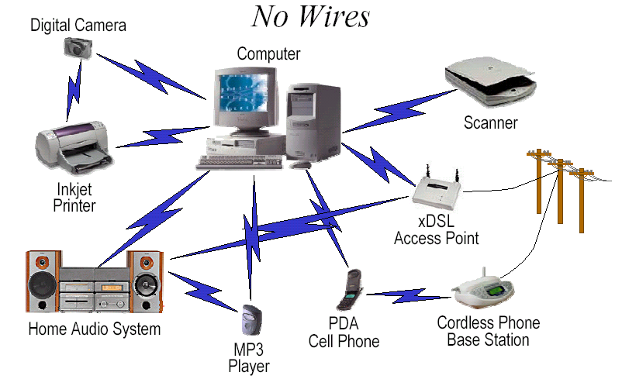

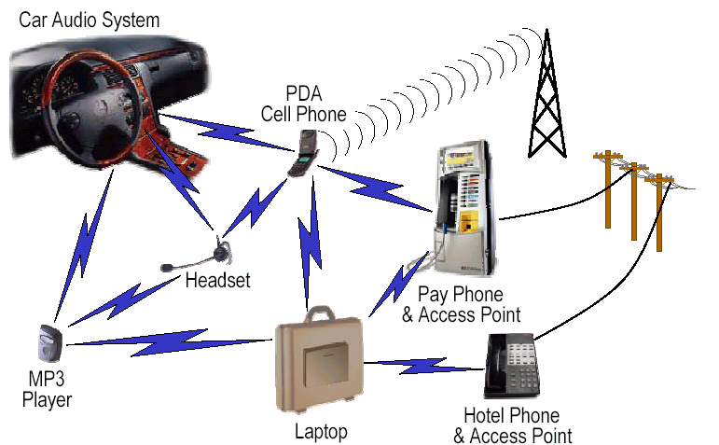

FIGURE 2.2.1

2.2.2 BLUETOOTH PROTOCOL STACK

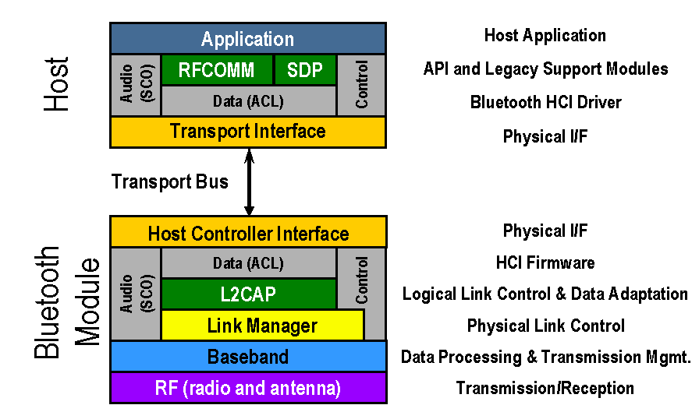

FIGURE 2.2.2

- Application Program Interface (API) libraries - These are software modules which connect the host application program to the Bluetooth communications system. As such they reside and execute on the same processing resource as the host system application.

- Service Discovery Protocol (SDP) - The Service Discovery Protocol, or SDP, provides a means for applications to discover which services are available and to determine the characteristics of those available services.

- RFCOMM - The RFCOMM protocol provides emulation of service ports over the L2CAP protocol. It covers applications making use of serial ports of their devices. It is a transport protocol with framing and multiplexing, supporting up to 60 simultaneous connections between two Bluetooth devices. At least two applications on the communication endpoints are needed for a complete communication path.

- Host Controller Interface (HCI) - The HCI provides a uniform interface method of accessing the Bluetooth hardware capability. During the initialization sequence, the HCI creates read and write threads, establishes a connection to the Bluetooth transport, and performs a reset and read of device buffer sizes. It then enters an initialized state and is ready to accept clients. HCI events, unlike with other layers of the stack, are sometimes caused by executing commands. The HCI layer matches events to commands currently in execution and returns a call context for the executing command (and retire the command) only when a corresponding event has signaled.

- Logical Link Control and Adaptation Protocol (L2CAP) - The L2CAP is the big picture brains of a Bluetooth system. It manages the high level aspects of each connection (who is connected to who, whether to use encryption or not, what level of performance is required, etc.). In addition it is responsible for converting the format of data as necessary between the APIs and the lower level Bluetooth protocols. The L2CAP is implemented in software and can execute either on the host system processor or on a local processor in the Bluetooth system.

- Link Manager - The Link Manager is responsible for managing the physical details for Bluetooth connections. It is responsible for creating the links, monitoring their health, and terminating them gracefully upon command or failure. The link manager is implemented in a mix of hardware and software.

- Baseband - The baseband is the digital engine of a Bluetooth system. It is responsible for constructing and decoding packets, encoding and managing error correction, encrypting and decrypting for secure communications, calculating radio transmission frequency patterns, maintaining synchronization, controlling the radio, and all of the other low level details necessary to realize Bluetooth communications.

- Radio - The Bluetooth radio converts the digital baseband data to and from a 2.4GHz analog signal using Gaussian Frequency Shift Keying (GFSK) modulation.
2.2.3 BLUETOOTH IN ACTION

The following figure illustrates how Bluetooth devices connect into Piconets (a Master device with 1 to 7 Active Slave devices) and Scatternets . Bluetooth devices have four basic States. They can be a Master, an Active Slave, a Passive Slave, and Standby.

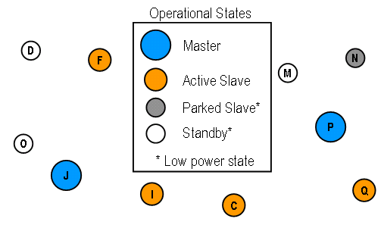

FIGURE 2.2.3.1

Bluetooth devices initially know only about themselves and in this state they will be in Standby mode. Standby is a passive mode where a Bluetooth device listens on an occasional basis performing what are called Inquiry and/or Page Scans for 10 milliseconds out of every 1.28 seconds to see if any other Bluetooth devices are looking to communicate. Passive behavior is inherent to half of Bluetooth’s states and is a key mechanism to achieving very low power. In Standby mode the Bluetooth device’s occasional attention reduces power consumption by over 98%. While all of the Bluetooth devices in the illustration below are in the same mode it is important to note that they are NOT synchronized or coordinated in any way. Thus they are all listening at different times and on different frequencies. (See figure 2.2.3.2)
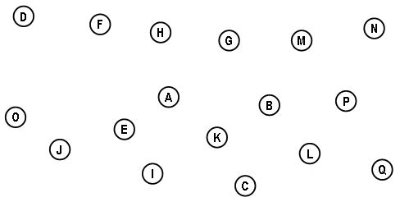

FIGURE 2.2.3.2

Inquiry is how a Bluetooth device learns about other devices that are within its range. In the figure 2.2.3.3 Node A executes a Page Function on the BT Inquiry ID and receives replies from devices B, C, E, F, G, I, J, and K. Through these replies device A learns the explicit identity of these other devices (i.e. their unique Bluetooth device ID). During the Inquiry process device A continuously broadcasts the Page command using the reserved Inquiry ID which identifies it as a Page Inquiry. These broadcasts are spread across a standard pattern of 32 Standby radio frequencies which all devices in Standby mode monitor on an occasional basis. Over duration of some seconds it is certain that every Standby device within range will have received the Inquiry Page even though they are not synchronized in any way. By convention these nodes will respond with a standard FHS packet that provides their unique BT ID and their clock offset. With these parameters the Inquiring node can effect low latency synchronized connections.
Node H (the dotted circle above) illustrates how a Bluetooth device can be programmed to remain anonymous (Undiscoverable in BT jargon). This is a user controlled feature that suspends Inquiry Scanning, and thus device A’s Inquiry Procedure cannot discover Device B It is important to note that device H will continue to support Page Scanning however, and thus a user’s other personal devices (i.e. PAN) can penetrate this barrier by Paging directly to its unique Bluetooth ID. This is information that PAN devices can be configured to know and remember thus enabling private collaboration even when devices are undiscoverable.
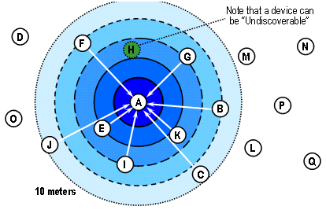

FIGURE 2.2.3.3

In its general form the Page command establishes a formal device to device link between a Master (the originator) and a Slave. Master/Slave connections in Bluetooth are referred to as a Piconet. To create the piconet device A broadcasts the Page command with the explicit device ID of the target Slave (B in the figure 2.2.3.4) which was learned earlier through an Inquiry Procedure. Further, this connection can be very low latency if the Inquiry data is recent (and thus synchronization can be accurate), but the process will simply take longer if this is not the case. All Bluetooth devices except B will ignore this command as it is not addressed to them. When the device B replies, device A will send it an FHS packet back and assign it an Active Member Address in the Piconet.
As an Active Slave device B will begin continuously monitoring for further commands from device A in synchronization with device A’s hopping pattern and clock offset. Further, standard Piconet activity continuously updates the clock offset data keeping the synchronization extremely accurate. Thus the Master and Slave states are not low power but exhibit very low transaction latencies.
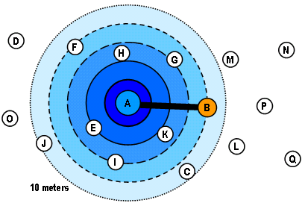
FIGURE 2.2.3.4
Through successive Page commands a Bluetooth Master can attach up to 7 Active Slaves. 7 is a hard limit as only 3 bits are allocated in Bluetooth for the Active Member Address (AMA) with 000 reserved for the Master and the remaining addresses allocated to Slaves. Practically, 7 is more than sufficient given Bluetooth’s modest performance and dynamic configurability. Again, all Active Slaves to A continuously monitor for further commands addressed to them in synchronization with device A’s hopping pattern. (See figure 2.2.3.5)
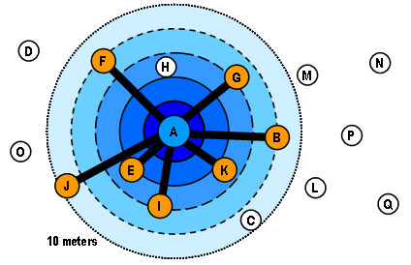

FIGURE 2.2.3.5
Parking is a mechanism that allows a Bluetooth Master to connect to an additional 256 devices. 256 is a hard limit as 8 bits are allocated in Bluetooth for the Parked Member Address (PMA).To Park a device the Bluetooth Master issues a Park command to an Active Slave and assigns it a PMA. This Slave then enters the Parked mode and surrenders its AMA. As a Parked Slave the device will revert to a passive mode and only monitor for commands on an occasional basis. The difference between Standby and Parked however is that the Slave will remain synchronized to the Master’s hopping pattern and regularly update its clock offset. Thus this device can be reconnected at any time with a minimum latency. (See figure 2.2.3.6)

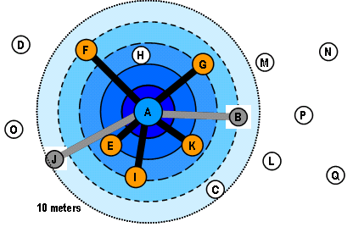

FIGURE 2.2.3.6

As Active Member Addresses are freed by Parking previously Active Slaves the Bluetooth Master is free to recycle them and attach other nodes as Active Slaves. In the illustration above Device A has added nodes H and C to its Piconet with the AMAs released by parking nodes B and J. (See figure 2.2.3.7)
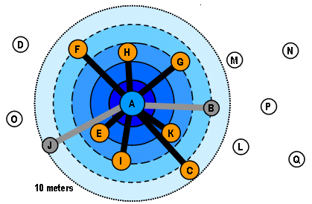

FIGURE 2.2.3.7

Each Bluetooth node is capable of maintaining multiple states simultaneously. This allows multiple Piconets to combine together into a structure called a Scatternet. In the figure 2.2.3.8 Piconets combine into a Scatternet through the common slaves E and I.

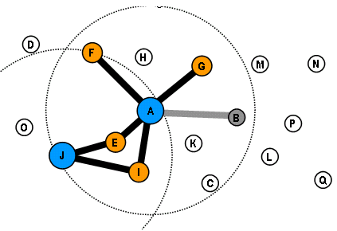

FIGURE 3.2.3.8

Scatternets can evolve into extremely complex structures as illustrated in figure 2.2.3.9. Note that node B is now a Master, an Active Slave, and a Parked Slave on 3 different Piconets all at the same time. The only hard limitation on scatternet configurations is that each Bluetooth node can only be the Master of one Piconet at any given time.
It is important to note here that a key feature making such configurations practicable is the support for Quality of Service (QoS) in the L2CAP. Through this mechanism Bluetooth devices are able to determine that the connections they are establishing are feasible and sustainable. Thus, node B above would not agree to an additional connection if it would require bandwidth that it is unable to support. Further, it may well negotiate to establish another connection, but at a more modest data rate that it can support.
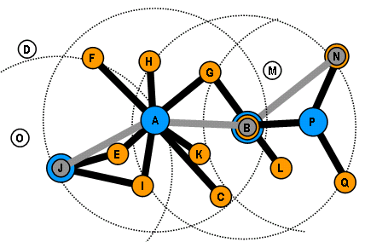

FIGURE 2.2.3.9

2.2.4 INTERFERENCE ISSUES:

One of the ways Bluetooth devices avoid interfering with other systems is by sending out very weak signals of 1 mill watt. By comparison, the most powerful cell phones can transmit a signal of 3 watts. The low power limits the range of a Bluetooth device to about 10 meters, cutting the chances of interference between your computer system and your portable telephone or television. Even with the low power, the walls in your house won't stop a Bluetooth signal, making the standard useful for controlling several devices in different rooms. With many different Bluetooth devices in a room, you might think they'd interfere with one another, but it's unlikely that several devices will be on the same frequency at the same time, because Bluetooth uses a technique called spread-spectrum frequency hopping. In this technique, a device will use 79 individual, randomly chosen frequencies within a designated range, changing from one to another on a regular basis. In the case of Bluetooth, the transmitters change frequencies 1,600 times every second, meaning that more devices can make full use of a limited slice of the radio spectrum. Since every Bluetooth transmitter uses spread-spectrum transmitting automatically, it’s unlikely that two transmitters will be on the same frequency at the same time. This same technique minimizes the risk disruption of Bluetooth devices, since any interference on a particular frequency will last only a tiny fraction of a second. When Bluetooth-capable devices come within range of one another, an electronic conversation takes place to determine whether they have data to share or whether one needs to control the other.
The user doesn't have to press a button or give a command -- the electronic conversation happens automatically. Once the conversation has occurred, the devices whether they're part of a computer system or a stereo form a network. Bluetooth systems create a personal-area network (PAN), or Piconet. Once a piconet is established, the members randomly hop frequencies in unison so they stay in touch with one another and avoid other piconets that may be operating in the same room.

2.3 COMPLEMENTARY TECHNOLOGIES
The complementary technologies which we can talk about for Bluetooth are IrDA (Infrared Data Association), RF signaling (Radio Frequency), Wi-Fi (Wireless Fidelity). The other technologies have their own flip sides.
2.3.1 IrDA:

IrDA is faster than the Bluetooth wireless technology but is limited to point-to-Point connections and above all it requires a clear line-of-sight. In the past IrDA have had problems with incompatible standard implementations, a lesson that the Bluetooth has learned.

2.3.3 HOME RF:

Home RF has many similarities with the Bluetooth wireless technology. The hop frequency is 8 Hz while a Bluetooth link hops at 1600 Hz. Moreover it does not support discovery and synchronization of devices.

2.3.3 Wi -Fi (802.11b):

The transmission capacity is high and so is the number of simultaneous users. On the other hand it is, compared to Bluetooth wireless technology, more expensive, power consuming and the hardware requires more space and it is therefore not suited for small mobile devices.

2.4 OVERVIEW OF SYMBIAN

2.4.1 INTRODUCTION TO SYMBIAN OS

Symbian OS is the advanced, open operating system licensed by the world's leading mobile phone manufacturers. It is designed for the specific requirements of advanced 2G, 2.5G and 3G mobile phones. Symbian OS combines the power of an integrated applications environment with mobile telephony, bringing advanced data services to the mass market.
Symbian OS is a powerful aligning force for the wireless value chain, driving the wireless industry. Mobile phone manufacturers, network operators and software developers are assured that they are working with an industry standard, open operating system that allows customization and is focused on the mass market.
Symbian OS is designed to support innovation and customization by licensees. Compact enough to fit in the memory of a mobile phone, Symbian OS was planned from the beginning to be a full operating system in terms of functionality. It includes a robust multi-tasking kernel, integrated telephony support, communications protocols, data management, advanced graphics support, a low-level user interface framework and a variety of application engines.

2.4.1.1 PROVIDING WIRELESS SERVICES

Open standards ensure global network interoperability, allowing mobile phone users to communicate with anyone, any way, at any time. The compelling advanced data services that operators can provide on Symbian OS phones will help minimize churn and maximize revenue.

2.4.1.2 Developing wireless services

Software developers are able, for the first time, to build applications and services for a global mass-market of advanced, open, programmable, mobile phones. A set of standard application programming interfaces (APIs) across all Symbian OS phones and the advanced computing and communications capabilities of Symbian OS enable development of advanced services.

2.4.1.3 Key characteristics of Symbian OS

- Integrated Multimode Mobile Telephony - Symbian OS integrates the power of computing with mobile telephony, bringing advanced data services to the mass market. Symbian OS is the operating system of choice for 2.5G and 3G mobile phones.

- Messaging - Symbian OS includes comprehensive support for SMS, MMS, email and fax. Peer-to-peer multimedia messaging is a key revenue generator for 2.5G and 3G networks.
- Open Application Environment - Symbian OS enables mobile phones to be a platform for deployment of applications and services (programs and content) developed in a wide range of languages (Java and C++) and content formats.

- Standards and Interoperability - With a flexible and modular implementation, Symbian OS provides a core set of application programming interfaces (APIs) and technologies that is shared by all Symbian OS phones. Key industry standards such as IP v4 and v6, Bluetooth, Java, WAP and SyncML are supported.

- Multitasking - Fully object-oriented and component-based, Symbian OS includes a multi-tasking kernel, middleware for communications, data management and graphics, the lower levels of the graphical user interface framework, and application engines.

- Robustness - Symbian OS maintains instant access to user data. It ensures the integrity of data, even in the presence of unreliable communication, and limited resources such as memory, storage and power.

- Flexible User Interface Design - By enabling flexible graphical user interface design on Symbian OS, Symbian is fostering innovation and is able to offer choice for manufacturers, carriers, enterprises and end-users. Using the same core operating system in different designs also eases application porting for third party developers.

2.4.1.4 User interface customization

Symbian OS provides a flexible user interface (UI) framework that enables mobile phone manufacturers to differentiate their products while keeping the learning curve for developers to a minimum. Advanced mobile phones will come in many forms: from designs resembling today's mobile phones with main input via the phone keypad, to tablet form factor which can be operated one-handed with a stylus, to keyboard-based phones with larger screens and small keyboards. The different input mechanisms and form factors strongly influence the intended primary use of these phones. User interfaces are ultimately both device and market dependent.
Symbian OS is a blend of extensive APIs which provides the mechanisms for the development of the Interactive User Interfaces, Communication Architectures and etc. With an orientation towards the Bluetooth Technology, how the communication is established, how the transmission of the Data is handled is dealt here.

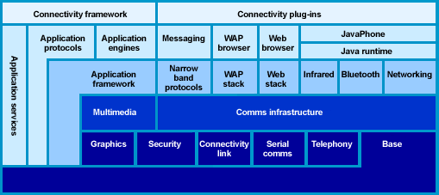

FIGURE 2.4.1.4.1
With Symbian OS, mobile phone manufacturers and third parties can produce innovative UIs for families of mobile phones such as Nokia and Sony Ericsson. Nokia launched the Series 60 Platform which runs on Symbian OS and supports native Symbian OS applications and Java applications. The Nokia 7650 features the Series 60 Platform user interface (See Figure 2.4.1.4.2). The present application has been developed on Nokia Series 60 SDK for Symbian OS to run on phones supporting Series 60 platform such as Nokia 3650 and Nokia 7650.
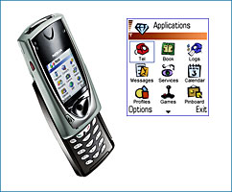

FIGURE 2.4.1.4.2

2.4.1.5 KEY FEATURES OF SYMBIAN OS VERSION 6.1

- Messaging-internet, email usingPop3,IMAP4, SMTP, MHTML; standard attachments including Microsoft Word documents; fax; text messaging using SMS.

- Communication Protocols – TCP/IP, WAP, Bluetooth, IrDA, serial.

- Security – Full-strength encryption and certificate management, secure communications protocols (including HTTPS, WTLS and SSL), certificate-based application installation.

- Rich suite of application engines, including contacts, schedule, messaging, browsing, voice, office, utility and system control.

- Object Exchange – OBEX is used to exchange objects such as appointments and business cards.

- Multimedia Server – support for several audio and image formats.

- International locale support with Unicode characters, flexible text input framework, handwriting recognition, and additional font and text formatting support (supporting the Unicode Consortium standard).

- Four main programming and content development options – C++, Java (including Java Phone), WAP, and web.

- Data synchronization with PC-based applications using Symbian Connect.

- Support for Multiple User Interfaces – Keyboard-based and/or pen-based information-centric mobile phones, and advanced data-enabled mobile phones.
2.4.1.6 ISSUES OF THE MOBILE DEVICE
- Limited screen space
- Limited input
- A different usage pattern
- Limited memory
The powerful features of the Symbian OS makes it feasible for the development of Interactive User Interfaces. It provides the following handy classes for the development of the following User Interface tools such as menus, textboxes, list boxes etc:
- Text | Text is used as an item of the setting list
- Slider | The slider gauge is used as an item of the setting list
- Volume | The volume gauge is used as an item of the setting list
- Enumerated text | The options list is used as an item of the setting list
- Date | The date is used as an item of setting list
- Time | Time is used as an item of the setting list
- Binary | On/Off is used as an item of the setting list
- Alphabetic password | The alphabetic password is used as an item of the setting list
- Numeric password | The numeric password is used as an item of the setting list
- IP address | IP address style is used as an item of the setting list

The detailed screen shots about the resources are given in the Software Requirements Specifications of the project. Sample User Interfaces are given below:

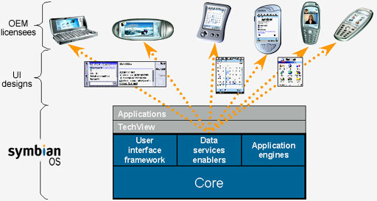
FIGURE 2.4.1.6

2.4.2 INTRODUCTION TO SYMBIAN C++
C++ for advanced applications: Symbian OS itself is written largely in C++ and the language therefore represents a strong development choice for third parties. Symbian's use of C++ is efficient, thoroughly object-oriented, and provides access to all the APIs. To aid in porting engine and communications code from other systems, the C Standard Library provides a Posix-compliant (Portable Standard for UNIX) API set, layered on top of the more fundamental C++ APIs.
Writing C++ code for Symbian OS is in some ways different to writing C++ code for other operating systems. This is because Symbian OS uses software to get the most out of limited hardware resources, and this affects the software at every level, including application code. Writing code for Symbian OS means getting used to a few programming idioms, such as

techniques to guard against memory leaks. However, these idioms produce benefits in terms of the efficient use of hardware resources. In writing a Symbian OS application you are involved in engineering the effectiveness of the system as a whole.
2.4.2.1 NOKIA SERIES 60 SDK FOR SYMBIAN OS

The Series 60 Developer Platform brings open standards and multivendor volume to the smartphone market. Series 60 Developer Platform 2.0 builds on the previous release by providing: Symbian OS v6.0s native APIs; Java (MIDP 2.0), CLDC 1.0, Wireless Messaging API (JSR-120), Mobile Media API (JSR-135), and Bluetooth API (JSR-82); XHTML browsing over TCP/IP.
Series 60 Platform is a new terminal software product available for licensing by terminal manufacturers. It enables terminal manufacturers to create application-driven smartphones that provide users with a richer mobile experience. Easy to use, interoperable with a wide range of standards, and designed to take advantage of the new mobile services, phones based on the Series 60 Platform will be part of a larger unified applications market that everyone can enjoy.
The other platforms available for developing Symbian applications for mobile devices are Series 40, Series 80, and Series 90.

2.4.2.2 THE EPOC EMULATOR
The applications developed on the Series 60 platform are compiled in the DOS environment, the output of the compilation can be viewed in the emulator which is called the EPOC emulator that comes bundled with the SDK. The snapshot of the emulator can be viewed in figure 2.4.2.2. The user interface of the emulator is similar to that of a mobile phone, the running of the application on the mobile phone is assured if it runs on the emulator.

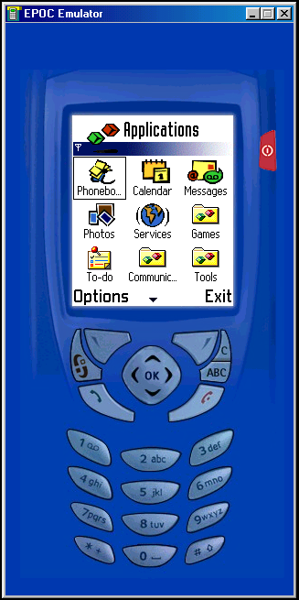

FIGURE 2.4.2.2

SYSTEM SPECIFICATIONS

3.1 HARDWARE SPECIFICATIONS
Class B Bluetooth Adapter for PC
TECHNICAL SPECIFICATIONS
General Functions
- Supports up to 7 slave devices
Standards
- Bluetooth 1.1
- USB 1.1
Transfer Rates
- 723 Kbps Asymmetrical max.
- 433.9 Kbps Symmetrical max.
Data Encryption
128-bit
Receiver Sensitivity
-80 dBm typical across passband under high interference Environments
RF Technology
Frequency Hopping Spread Spectrum
RF-Wireless Frequency
- 2400 to 2483.5 MHz for USA/Europe/Japan
- 2446.5 to 2483.5 MHz France
Range
Up to 25 meters peer-to-peer
- Bluetooth enabled mobile device supporting Series 60 platform
- Pentium IV 1.5 GHz. Processor
3.2 SOFTWARE SPECIFICATIONS

- Nokia Series 60 SDK for Symbian OS
- Visual Basic 6.0
- Windows 98SE, 2000, ME, XP

SOFTWARE REQUIREMENT SPECIFICATION

The necessity to communicate from one place to other irrespective of the distance led to the innovation of the Telecommunication Systems. Later the communication demanded wireless media for free mobility. Hence Cellular Communication is a break through in the field of Telecommunications.

The advancements in the communication technology made cell-phone to be connected to the internet, an Information Superhighway, increased the horizon of its capabilities. The simultaneous development in the hardware decreased the component size and the software led to the development of efficient and effective protocols that resolved many communication hazards such as propagation delay, data loss, intruder attacks etc.
The advancements in the protocol, set of rules making the communication feasible, increased the horizon of connectivity, connecting a Cell-Phone to another and computer and even any electronic and mobile devices such as PDA, Pager, Laptop and even a television, refrigerator, Microwave Owen and any consumer electronic device…

4.1 General Requirements

4.1.1 Native Environment
4.1.1.1 Client Icon
The PC remote controller application shall appear as an appropriate icon in the applications folder or section of mobile phones.
4.1.1.2 Platform
PC remote controller application shall be based on Symbian Series 60 Platform. Hence the application shall conform to Symbian platform requirements.

4.1.1.3 Language
PC remote controller Application shall be using the C++ API of the Symbian Platform and the whole application shall be developed in C++ Language.
4.1.1.4 API
PC remote controller Application shall be using the Bluetooth API provided by Symbian Series 60 Platform for discovering the primary protocol of communication for the application.
4.1.2 General Screen Layout

4.1.2.1 Screen Components
All screens shall have the following in common:
- Screen name (title) on top of screen
- Content display area
- Options button on the lower left corner. By clicking on this button, the user shall be shown the options available to him /her on that screen.
- Exit button on lower right corner. This button should allow the user to exit from the application, from any screen in the application.

4.1.3 Errors and Warnings
4.1.3.1 Error Message Screen
Errors are displayed as a pop-up fashion. Whenever there is a problem with the application either because of some internal problem or because of the network or host device problem, the error shall be displayed clearly and promptly to the end user. Error pop-up shall have a “” to clearly indicate that this is an error message. The error automatically vanishes in a few seconds
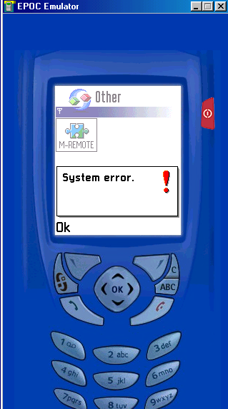
Figure 4.1.3.1
4.1.3.2 Informational Screen
Operation informational status shall be displayed to an end user via an informational pop-up screen. The screen shall have a “”to indicate that is an informational message. To close the informational screen, the user shall click “OK”.

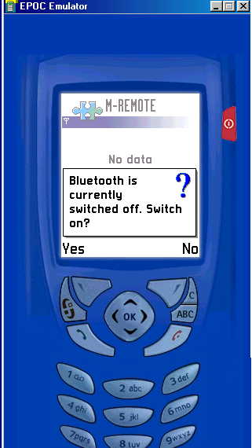

FIGURE 4.1.3.2

4.1.4 GUI Navigational Screens

      - user login:

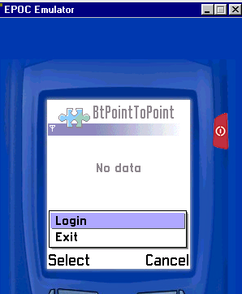

figure 4.1.4.1

4.1.4.2 connect to the PC REMOTE CONTROLLER Screen
When the user clicks the first option in the main menu, the mobile device is connected to the PC remote controller application.
FIGURE 4.1.4.2

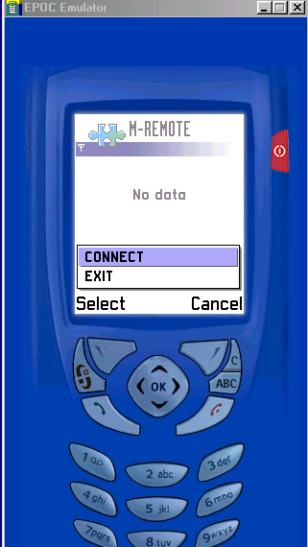

4.1.4.3 Main Menu Screen
The Main Menu Screen shall have a welcome message, from where the user has the option to view the available options by clicking the “Options” button.

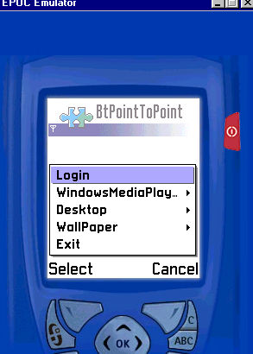
figure 4.1.4.3

4.1.4.4 ENTERTAINMENT
After clicking the second option in the main menu, the user is shown a list box which shows him the entertainment options on clicking it we get the “VIDEO” & “AUDIO” options so that we can select any of the media player files.
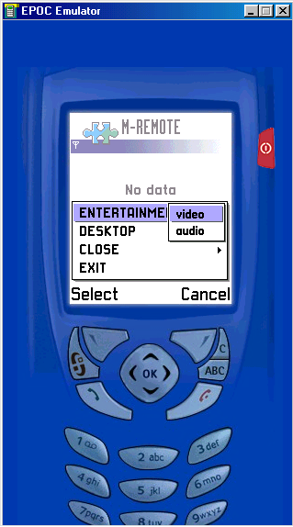

FIGURE 4.1.4.4

4.1.4.5 Media Player Controls
After clicking the Entertainment option we can select “Video “ or “Audio” files & on selecting further any one of it he gets various controls of the Media Player are displayed. The screen of controls is shown below
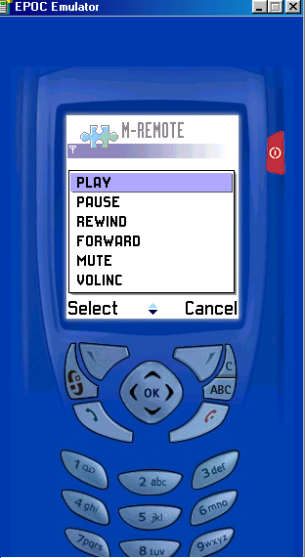

FIGURE 4.1.4.5

4.1.4.6 DESKTOP
After clicking the third option in the main menu, the user is shown a list box which shows him two more options; they are as shown in the screen. The user can view the list of various images to change the background.
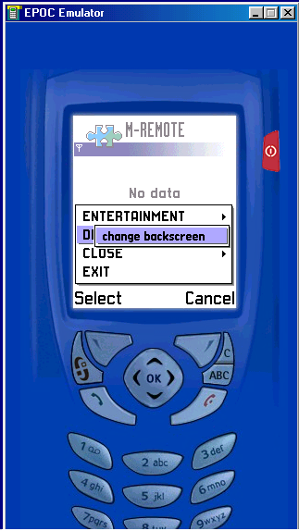
FIGURE 4.1.4.6
4.1.4.7 CLOSE
After clicking the fourth option, the user is shown a list box with the various closing options in it, he can either logoff ,shutdown & restart the pc.
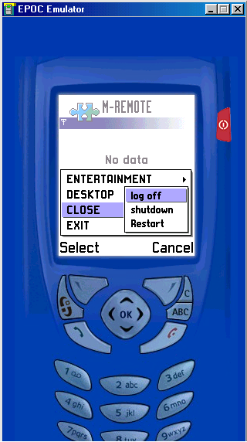
FIGURE 4.1.4.6

4.1.5 GUI Navigational Screens (RECEIVER side)
4.1.5.1 listener application screen
This is the application that is constantly running on the receiver side at the pc. This application send and receives data through the COM port of the computer, the Bluetooth adapter also receives and sends the data from the application through the COM port. This listener application in turn runs the V.B program.

4.1.5.2 mediaplayer screen
This is the screen that is shown when a song is being played on the receiver side.
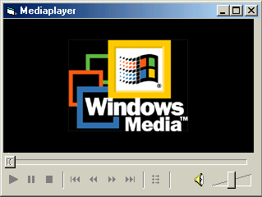

FIGURE 4.1.5.2

DETAILED DESIGN

5.1 BLOCK DIAGRAM

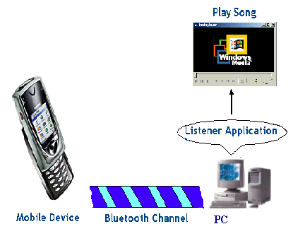

FIGURE 5.1

The above block diagram pictorially represents the PC remote controller application. Initially the listener application is started on the PC and is run on the COM port that is provided for the serial service on the Bluetooth adapter of the PC. The listener application processes all the requests that arrive on the COM port by taking relevant action. The Listener application keeps checking for new devices. On finding new devices, it sends a connection request to that particular mobile device. The user now has the option to either accept or reject the request. If he accepts the connection, the “.SIS” file that is the application is sent to the mobile device as a message. The application gets installed on the mobile device by accepting proper button clicks from the user. Now the application is ready for navigation. The user has to connect to the pc which is running the listener application prior to making any selections. Once the selection is sent to the listener application, intelligent processing of the request takes place If the request is a song, it will be played by the windows media player. The user can terminate the connection by selecting “Exit” on the navigational screen.
5.2 SUBSYSTEMS

This project has been dealt in three modules
- Design of Interactive User Interface for the Mobile Phone in Seriers 60 SDK on Symbian C++ for Symbian Operating System.
- Communication over Bluetooth using sockets.
- Design of listener application - A program written in Visual Basic to access the database and activate the Windows Media Player.

5.2.1 DESIGN OF USER INTERFACE

The design of a user friendly GUI adds flavor to this application. The GUI for the application is designed on the Series 60 platform for Symbian OS using C++ conventions. The GUI resources are added in the resource file (“.rss”). The handle commands for these resources are defined in the Btpointtopoint.hrh file. The control of these resources is taken by Application User Interface source file (BtpointtopointAppUi.cpp) and the HandleCommandL function call in this file carries out the handling of the user commands. The application starts at BtpointtopointApplication.cpp. The constructor of the application source file creates an instance of the document class, CBtpointtopointDocument. The document object is responsible for the collection and storing of data of the application with which the user interacts. An instance of Application User Interface class,CBtpointtopointAppUi is created in BtpointtopointDocument.cpp. The Application User interface takes the control from here, creates the instances of view class, CBtpointtopointView and Client, CMessageClient and handles the commands selected by the user. Once the complation of code is done, “.app” and “.rsc” files are created which are used for the emulation of the application on the EPOC emulator. The application is first tested on the EPOC emulator and a working “.SIS” file is created. The GUI screens for the application have been shown in the Software Requirement Specification.

5.2.2 BLUETOOTH COMMUNICATION

5.2.2.1 BLUETOOTH SOCKETS

Bluetooth sockets API, discovers other Bluetooth devices and reads and writes data over Bluetooth. This provides a Socket Client-Side programming environment to program both at the receiver and initiator sides for communication by creating a socket(an addressed buffer area) on which the receiver sets-up initially and the initiator establishes the connection by accepting it, from there on either of the devices can send / receive / terminate connection via socket.

5.2.2.2 BLUETOOTH SERIAL SERVICE

Bluetooth serial service is the Application Framework example literally given by the Symbian OS which is very handy to send the messages from the Mobile Phone to the other Bluetooth device, using the Bluetooth Serial Port service. All the resources defined in the User Interface Section have been implemented in this Application Framework.

5.2.2.2.1 Receiving mechanism
In particular it demonstrates the device receiving the message:
- Initializing the Serial Port service.
- Authorizing acceptance of a connection from another device.
- Advertising the service on its Service Discovery Protocol (SDP) database.
- Listening for a connection from another device.
- Receiving the incoming message.
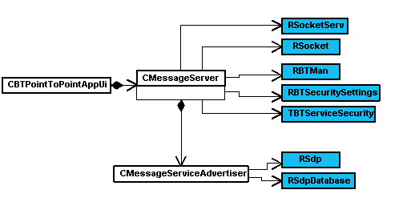

FIGURE 5.2.2.2.1
CBtpointtopointAppUi is the application view class for the application. It uses an instance of CMessageServer to
- Initialize the Bluetooth Serial Port service.
- Authorize the acceptance of a connection from another Bluetooth device.
- Advertise the Bluetooth Serial Port service.
- Listen for a socket connection over Bluetooth.
- Accept a socket connection.
- Receive the message from the sending device over Bluetooth.
CMessageServer uses several Symbian OS classes:
RSocket which provides a client endpoint to a protocol. RSocket provides functions for socket creation and reading from a socket. Two instances of RSocket are used, iListeningSocket for listening for connections and iAcceptedSocket for receiving the message from the sending device.
RBTMan and RBTSecuritySettings provide a session to the Security Manager which is used to register and unregister services with the security manager. TBTServiceSecurity is a structure containing security settings of a Bluetooth service.
CMessageServer uses CMessageServiceAdvertiser to advertise the Serial Port service. This in turn uses two Symbian OS classes: RSdp and RSdpDatabase which together provide a session to the Bluetooth SDP database. Advertising the Serial Port Service is done by creating an appropriate record in the SDP database.
The UML sequence diagram below shows the functions calls and other interactions that occur between the objects involved in advertising services and receiving messages in the receiving device for the scenario.The diagram includes states which are represented by values of a CMessageServer state valiable called iState. This affects the flow of control in CMessageServer::RunL. The commentary which follows explains the interactions in detail.
5.2.2.2.2 SENDING mechanism
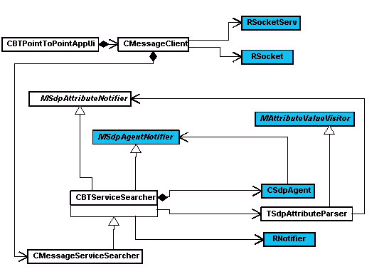
FIGURE 5.2.2.2.2
CBtpointtopointAppUi is the application user interface class for the Bluetooth Point To Point application. It uses an instance of CMessageClient to connect to the receiving device and send the message to it. The CMessageClient object uses the Symbian OS class, RSocket to open a socket to the receiving device and send the message.
Before it can open the socket, the CMessageClient object has to discover the receiving device, query its SDP database to find parameters relating to the Serial Port service.
To discover the device, it uses the Symbian OS class RNotifier. This is a handle to a session with the extended notifier server that provides support for plug-in notifiers, and specifically in this case, the Device Selection Notifier plug-in. The asynchronous function RNotifier::StartNotifierAndGetResponse is used to call the plug-in.
CMessageClient uses an instance of CMessageServiceSearcher to query the receiving device's SDP database and extract the channel number (i.e. port number) to use for the Serial Port service. The channel number is embedded in the SDP database record structure that was built by the StartAdvertisingL function of the CMessageServiceAdvertiser object in the receiving device.

Service Class ID List
  Serial Port Service Class UUID
Protocol Descriptor List
  L2CAP UUID
  RFCOMM UUID
  Channel number
Service Name | "Serial Port"
Service Description | "Simple point to point data transfer "
Service Availability | True

FIGURE 5.2.2.2.3

The CMessageServiceSearcher class is derived from a more general service searching object CBTServiceSearcher which connects to the receiving device's SDP database. It uses the Symbian OS Bluetooth class CSdpAgent which makes Bluetooth SDP requests to the receiving device. MSdpAgentNotifier handles responses to Bluetooth SDP queries. Clients that make queries through CSdpAgent must implement this interface to handle the responses and implement the callback functions AttributeRequestComplete(), AttributeRequestResult() and NextRecordRequestComplete(). CBTServiceSearcher also uses TSdpAttributeParser to parse the SDP records. TSdpAttributeParser uses a callback function in TSdpAttributeNotifier to notify CBTServiceSearcher when it has found a specific value in an attribute. The sending process begins when the user selects Connect on the sending device. This causes HandleCommandL to be called on the BTBtpointtopointUi object which in turn calls ConnectL on a CMessageClient object. The two UML sequence diagrams below show in detail what happens when ConnectL is called on the CMessageClient object. The commentary which follows each diagram explains the function calls.

5.2.3 THE LISTENER MODULE
The final module of the project is the creation of the listener application, an ever running program which keeps waiting for the data residing on the COM port and accesses the database or activates the controls Windows Media Player in the system. This is done by reading the information from the socket.
Hence the platform selected to develop such an application must satisfy the following features:
- The language must support a program that can always be executing.
- The program thus generated must have least response time.
- The program must be capable of reading data from the socket.
- The program must be capable of interacting with other programs.

All these features can be achieved by means of Visual Basic Programming Language because of its following powerful features.

- The robustness, reliability features of the Visual Basic made are best suitable for the application.
- It can handle the system resources and the system responses nicely.
- The ability to add & interact with the ActiveX controls able to easily handle the functionality of the Windows Media Player.

5.3 USE CASE DIAGRAM
FIGURE 5.3
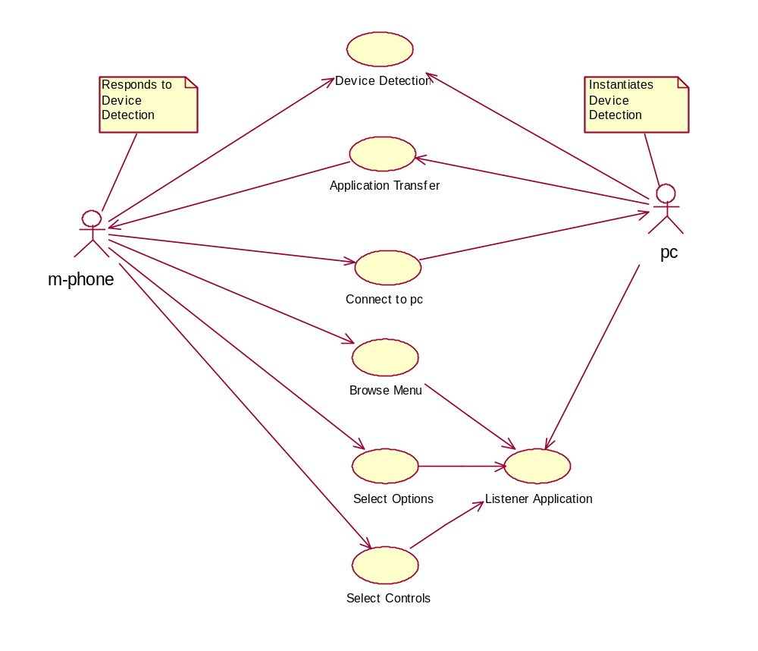

5.4 SEQUENCE DIAGRAM
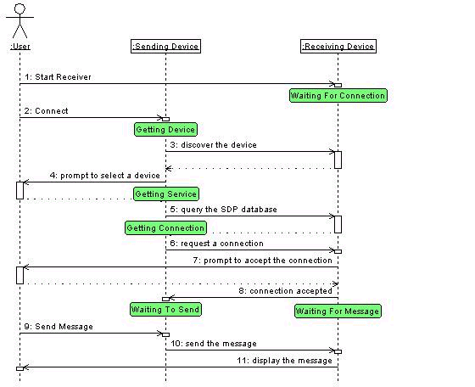

FIGURE 5.4

FIGURE 5.5
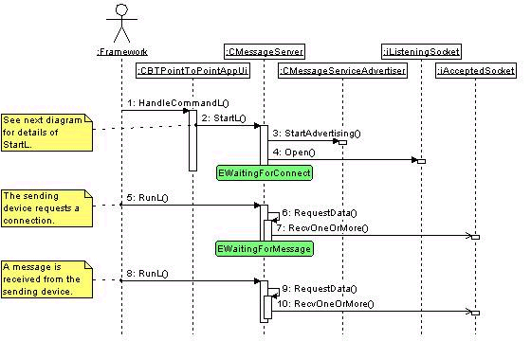

TEST CASES

6.1 TEST CASE TITLE: To establish a connection

Test case 1: connection |  | Priority (H, L): High
Test Objective: To check whether the connection is established.
Test Description: The user selects the “connection” option on the Mobile Phone, as a result of which messages “Service Found” and “Connected” should appear on the mobile Phone
Requirements Verified: Yes
Test Environment: Bluetooth enabled PC or any device, Bluetooth enabled mobile, Symbian OS, and the link must be configured.
Test Setup/Pre-Conditions: Receiver should be in connection accept state
Actions | Expected Results
The user will select Connect from Menu | “Service Found”, “Connected”
Pass: Yes Conditions pass: No Fail: No
Problems / Issues: NIL
Notes: Successfully Executed

6.2 Test for sending a message

Test case 3: Query reply |  | Priority (H,C) :Medium
Test Objective: To check whether the user is getting the reply for menu for the action he has performed.
Test Description: When the user clicks on any of the menu item, the respective attributes have to be retrieved.
Requirements Verified: YES
Test Environment: Two Bluetooth Devices, Symbian OS, and the link must be configured
Test Setup/Pre-Conditions: Connection is established between MOBILE and the PC
Actions | Expected Results
Entertainment | Upon clicking this option, user gets a cascaded menu items in which different options are displayed on the clients mobile screen
Pass: Yes Conditions pass: No Fail: No
Problems / Issues: NIL

Test case 2: Send message |  | Priority(H , C) :High
Test Objective: To check whether the Listener Program is Reading the message.
Test Description: When the use select any option from the menu,a message will be generated respectively and be sent to the listener program, After receiving the message the listener module will execute it accordingly.
Requirements Verified: Yes
Test Environment: Bluetooth enabled PC, bluetooth mobile phone
Test Setup/Pre-Conditions: Connection should be established from the sender to receiver
Actions | Expected Results
Select the option from the menu | The message is sent to the receiver
Pass: Yes Conditions pass: Fail: No
Problems / Issues: NIL
Notes: Successfully completed.

6.3 Test for query passing

6.4 Test for sending Video files

Test case5: Alerts |  | Priority(H,C) :High
Test Objective: To check whether the alerts are received
Test Description: Upon Mobile connected to the PC the mobile device should get the alert messages from the PC
Requirements Verified : Yes
Test Environment : Two Bluetooth Devices, Symbian OS, and the link must be configured
Test Setup/Pre-Conditions : Connection is established between PC and the Mobile
Actions | Expected Results
Connect | The alert messages from the PC are displayed
Pass : Yes Conditions pass : Yes Fail : No
Notes : Successfully completed

Test case 4: Video files (*.Dat files) |  | Priority(H , C) :Medium
Test Objective: To check whether the text is received by the Mobile
Test Description: Upon entering video file name in dialog box, it is checked up with the default movie in the list and the selected movie is sent to the Mobile.
Requirements Verified: YES
Test Environment : Two Bluetooth Devices, Symbian OS, and the link must be configured
Test Setup/Pre-Conditions: Connection is established between Mobile and the PC
Actions | Expected Results
Enter the movie name or by default it returns *.Dat files from the list | The movie name is checked with the list in the particular location and corresponding movie is displayedccc
Pass : Yes Conditions pass : Yes Fail : No
Notes : Successfully completed

6.6 - Testing Of COM Port

Test Case 2: | Priority: High
Test Objective: Testing whether the COM Port is active.

Test Description: To check whether the Listener application’s COM port and the serial service’s COM port on the Bluetooth Adapter should be same
Requirements Verified: YES
Test Environment: Bluetooth Adapter, Port Controller, Listener application must be configured
Test Setup/Pre-Conditions: None.
Problems/Issues: NO
Notes: Successfully completed.

CONCLUSION AND FUTURE SCOPE

CONCLUSION
Mobile Remote could successfully control the Windows Media Player, Change background screen of desktop and also can shut down, restart and log off the PC. Thus Mobile Phone can be extended to control any home appliance (like TV, Microwave Owen, Refrigerator etc.,.) for such a project Mobile Phone is a substantial base where the PC works like a Gateway and sends the control to the selected device.

APPENDIX
8.1 GLOSSARY

1. ACL Asynchronous Connection Less
2. AMA Active Member Address
3. API Application Programming Interfaces
4. BT Bluetooth
5. CLDC Connected Limited Device Configuration
6. COM Communication
7. DOS Disk Operating System
8. FHS Frequency Hopping Synchronization
9. GFSK Gaussian Frequency Shift Keying
10. HCI Host Controller Interface
11. HTTPS Hyper Text Transfer Protocol Secure
12. IMAP Internet Message Access Protocol
13. IP Internet Protocol
14. IrDA Infrared Data Association
15. JSR Java Specification Request
16. L2CAP Logical Link Control and Adaptation Protocol
17. MHTML Multipurpose Internet Mail Extensions Hyper Text Markup Language
18. MIDP Mobile Information Device Profile
19. OBEX Object Exchange
20. OS Operating System
21. PAN Personal Area Network
22. PDA Personal Digital Assistant
23. PMA Parked Member Address
24. POP Post Office Protocol
25. POSIX Portable Standard for UNIX
26. QoS Quality of Service
27. RF Radio Frequency
28. RFCOMM RS232 Serial Cable Emulation Profile
29. SCO Synchronous Connection Oriented
30. SDK Software Development Kit
31. SDP Service Discovery Protocol
32. SMS Short Messaging Service
33. SMTP Simple Mail Transfer Protocol
34. SSL Secure Sockets Layer
35. SyncML Synchronization Markup Language
36. TCP Transmission Control Protocol
37. UI User Interface
38. USB Universal Serial Bus
39. UUID Universal Unique Identifier
40. WAP Wireless Application Protocol
41. Wi-Fi Wireless Fidelity
42. WTLS Wireless Transport Layer Security
43. XHTML Extensible Hyper Text Markup Language

BIBILIOGRAPHY

1. Programming for the Series 60 Platform and Symbian OS
by Digia, Symbian Press

2. Bluetooth End to End by Diane McMichael Gilster
Wiley publication

3. Using Visual Basic for Applications 5 by Paul Sanna
Prentice - Hall India

4. Voice and Data Magazine, February 2004 Edition

5. The Unified Modeling Language User Guide by Booch, Rambaugh, Jacobson
Pearson Education

REFERENCES

1. http://www.bluetooth.com
2. http://www.xilinx.com
3. http://www.symbian.com
4. http://forum.nokia.com
5. http://www.wirelessweek.com
6. Nokia Series 60 SDK for Symbian OS

